

NAME: DANISH BALAJI 192512122
Exp No: 1 FLASHING OF LED USING AT89C51
AIM: To Write an assembly language program to flash the LED using AT89C51
PROGRAM CODE:
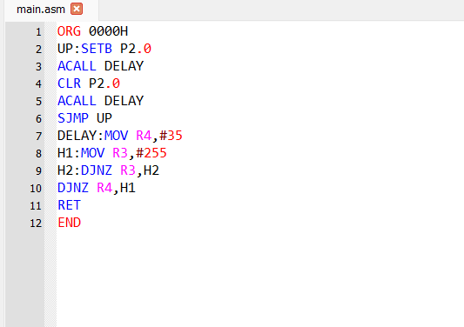
OUTPUT:
